Nano indenter (Bruker, TI PREMIER)
THIS INSTRUMENT REQUIRES TRAINING BY AN INSTRUCTOR
CONTACT TO: shuichi@chalmers.se
SOP ver.2 (2026.01.13)

- The nano indenter tip is sensitive. Don’t touch without the machine’s responsible person.

Starting up the Nano indenter
- Check the seismic isolation table is level (open the front door and check the indicator is in the middle)
- Turn on PC (inside the box below the seismic isolation table)
  - The order is important. Turn on the PC first
- Turn on the machine and the controller (Two buttons in the box)
- Turn on the microscope light (behind the PC monitor)
- Start software
  - If an error message appears, close the software in Windows Task Manager and restart it after a few minutes. Still, if it doesn’t work, restart the machine and the controller with the machine power button, wait a few minutes, and try to reopen the software
  - Initialization takes a few minutes
- Make a note of the temperature and humidity (important for reliable data)

Sample preparation
- Samples need to be securely fixed on the stage. Instability increases machine compliance and leads to a wrong result value
- Put the sample on the stage (don’t touch the indenter tip)

- Samples must be mounted rigidly to avoid increased machine compliance and erroneous displacement measurements. Double-sided tape some time show big compliance. Magnet mounting also shows compliance depending on the position.
- Higher samples should be placed on the right side of the stage (for smooth tip approaching)
- Samples placed on the sample stage should be spaced more than 3 cm apart. If samples are spaced closer than this distance, extreme damage may occur to the transducer, piezo scanner, and/or probe.

Open or create a workspace
- Go to ‘Sample Navigation’ window. Open the desired workspace or create a workspace
- The workspace contains settings, sample safety zones, automated method routines, data, in situ image files, etc.

Tare Value Verification
- The tare values of the system should be verified each time the transducer controller is powered on or any hardware components have been removed, replaced or modified
- Click the Calibration tab System Calibrations sub tab and click the Update button under the Tare Values heading
- Verifying that the tare value matches the value on the supplied transducer constants sheet (typically located within the black transducer case) indicates that the transducer and probe are installed correctly and that the connections are secure.
Air Calibrations
- Go to ‘System Calibration window’. Click update on system parameters
- Calibrate Indentation axis. This will automatically take you to ‘Load function’ window. Click ‘Calibrate Air Indent’ and then press Start.
- Ideally the RMSE should be below 5e-5. If it is, click Yes. Air calibration is complete.

- Air calibration is the process of measuring the load cell's spring constant. The spring constant can vary with temperature, humidity, or the probe’s mass, so this should be done daily.
- The Indentation Axis calibration procedure should be performed only when the probe is not in contact with any samples. Performing this calibration while the probe is in contact with a sample is unsafe and will produce an undesirable result.

Optic-Probe Tip Offset Calibration (can be skipped if not necessary)
- If the Scanner, transducer, or probe is removed or replaced, or any optical camera system hardware is adjusted, perform Optic-Probe Tip Offset Calibration according to the TI Premier User Manual, page 148. If not, skip this process.

Probe Calibration (can be skipped if not necessary)
- If a new probe is used, it must be calibrated. Or if the results start to deviate from the reference value (FQ) due to probe dulling, the probe needs to be recalibrated the Tip Area Functions (TAF).
- The probe calibration procedure requires the user to be familiar with the software operations.
- The protocol is in the TI Premier User Manual, page 159.

Reference (Fused Quartz) sample calibration
- Using ‘Sample Navigation’ window and focusing on the surface of Fused Quartz
- Click ‘Quick approach’. This will bring the tip to the sample surface; ensure the sample surface is in focus before proceeding to this step. For FQ, the in-focus distance is approximately 46.5 mm.

- The sample Last Contact Heights are cleared whenever the workspace is re-opened or the software is restarted. Before testing can continue, a Quick Approach must be re-run on all samples to be tested.
- Do not perform a quick approach procedure before an Optic-Probe Tip Offset calibration has been performed.
- Do not attempt normal operation of the instrument with the X/Y or Z Safety Disabled. This could cause the probe to crash into a sample, and extreme damage may occur to the transducer, piezo scanner, and/or probe.

- Go to ‘Load function’. Now click add segment. For fused quartz fill in the following params: (trapezoid_5mN load function)

Function | Time (s)
load | 5
hold | 2
unload | 5
 | Force (µN)
Peak force | 5000
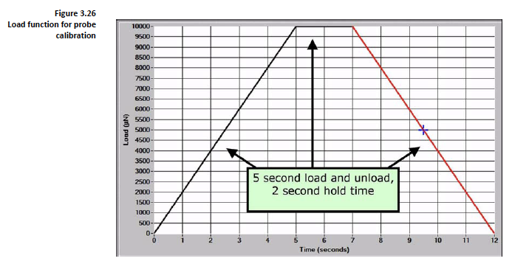

- Always make sure that the feedback is in ‘load control mode’.
- Once everything is set up, click ‘perform indent’.
- Once the scan is complete, save the data under TriboScan > Data > ‘Your folder’.
- Save sample name in the following format: ‘your name_date(YYYYMMDD)_sample details’.
- To check E and H, select ‘Tip area function (TAF)’ from ‘tip area’ tab.

- Use the latest TAF every time. If TAF is wrong, all the data will be wrong.

- Make sure that the young’s modulus (E) and hardness (H) match the values on the reference chart.
If not, follow :
- To make sure fit is good: If the start point is not at zero the fit would not be correct. To correct that remember the following controls:
- Ctr+Shft+left click to move left. (Make sure the red cursor is on the plot)
- Ctr+left click to zoom in.
- Click whichever point is zero and then press Ctr+G.
- Select tip area function under tip area tab.
- Click execute fit.
- To save data, click on txt option, this exports raw .txt file.
- If ‘a’ does not work, do the nine-point mapping on fused quartz in the ‘Automation’ tab:
- Choose the 9-point matrix (3x3), 8 µm distance.
- Click on edit properties: Method> indent. Enter file name, select folder.
- Click load function in Automation tab. Select load function for fused quartz. Input start and end load (5000 µN for fused quartz).
- Then, click on ‘Start method’ and click Yes. Make sure the load function selected is correct.

Sample measurement
- Once calibration is done, load your sample.
- Go to Sample navigation window, make sure that sample surface is focused. If not, click on the ‘z focus’ to focus your sample. +z brings the objective lens closer to the sample.
- Then click on the quick approach.
- To take the 9-point measurement on your sample, follow the same steps in 16b based on the material properties of your sample. For example, for PBFDO, load is 880 µN.
Note: for a new measurement, select the correct load function in the ‘load function’ tab by clicking on file and take a note of the drift settings.

Exporting data:
- Select the txt option. This will export raw data in a .txt file.
- To export calculated data, go to the MATLAB program, import .txt file from previous step, click execute and the save the calculate data.

